# Project: Analyzing a Market Test

## Step 1: Plan Your Analysis

1. What is the performance metric you’ll use to evaluate the results of your test?

The performance metric that will be used to evaluate the results of the test is gross margin, where the predicted impact to profitability should be enough to justify the increased marketing budget (at least 18% increase in profit growth compared to the comparative period while compared to the control stores).

1. What is the test period?

The test period is of 12 weeks (2016-April-29 to 2016-July-21) where five stores in each of the test markets offered the updated menu along with television advertising.

1. At what level (day, week, month, etc.) should the data be aggregated?

The data should be aggregated at the week level.

## Step 2: Clean Up Your Data

I aggregated the listing and transaction data in order to get the weekly store traffic and store sales analysis, afterward, joined the treatment stores in order to get a list with all the stores.

Note: Because the performance measure is gross margin and the reporting period is weeks, in addition to the 52 weeks, we also require another 12 weeks. Including the 12 week period of testing, 76 weeks of data (2015-02-06 to 2016-07-21) have been used for the A/B test.

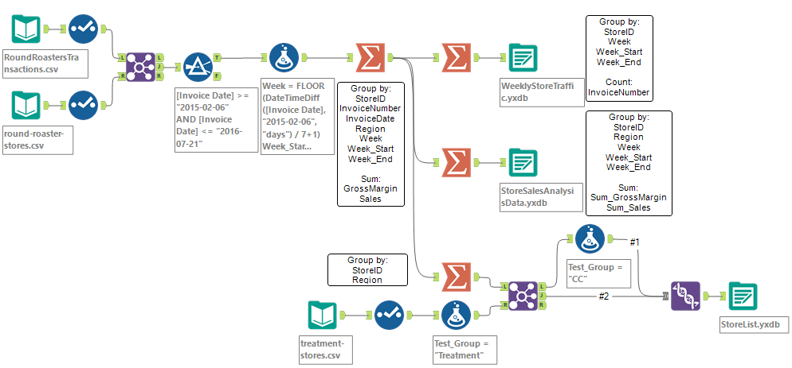

Fig. 2.1. Cleanup data Alteryx workflow

## Step 3: Match Treatment and Control Units

1. What control variables should be considered? Note: Only consider variables in the RoundRoastersStore file.

The control variables that should be considered are: AvgMonthSales and Sq_Ft.

1. What is the correlation between your each potential control variable and your performance metric?

Using the Pearson Correlation Analysis, with the performance metric Sum_Sum_Gross.Margin, only AvgMonthSales has a high correlation (0.79).

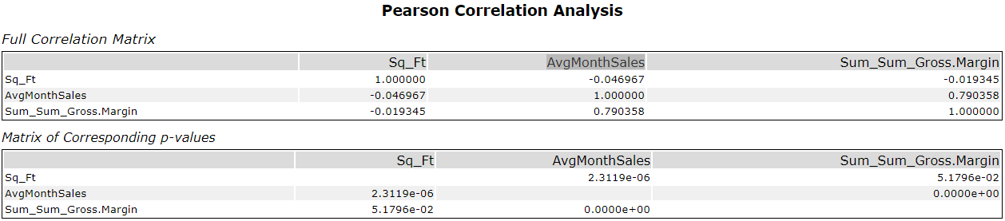

Fig. 3.1. Person correlation analysis.

1. What control variables will you use to match treatment and control stores?

Considering the p-value of AvgMonthSales (p-value < 0.05) this control variable is statistically significant, thus, it will be used when matching the treatment and control stores.

1. Please fill out the table below with your treatment and control stores pairs:

Tab. 3.1. Treatment and control stores pairs.

|  |  |  |
| --- | --- | --- |
| **Treatment Store** | **Control Store 1** | **Control Store 2** |
| 1664 | 1857 | 7484 |
| 1675 | 2114 | 8562 |
| 1696 | 1964 | 7584 |
| 1700 | 1508 | 7384 |
| 1712 | 7284 | 8212 |
| 2288 | 9081 | 12069 |
| 2293 | 11568 | 12219 |
| 2301 | 10018 | 10468 |
| 2322 | 2409 | 3102 |
| 2341 | 2333 | 11368 |

## Step 4: Analysis and Writeup

Based on the results of the A/B analysis, the company should roll out the updated menu to all of the stores because the profit growth meets more than 18% increase in profit growth compared to the comparative period while compared to the control stores.

1. What is your recommendation - Should the company roll out the updated menu to all stores?

The company should roll out the updated menu to all stores because there is more than 18% increase in profit growth compared to the comparative period while compared to the control stores.

1. What is the lift from the new menu for West and Central regions (include statistical significance)?

a. West – the report shows that the average lift as a result from rolling out the update menu showed a 32.1% improvement at a significance of 99.1% over the control stores, meaning, approximately $449 per store per week.

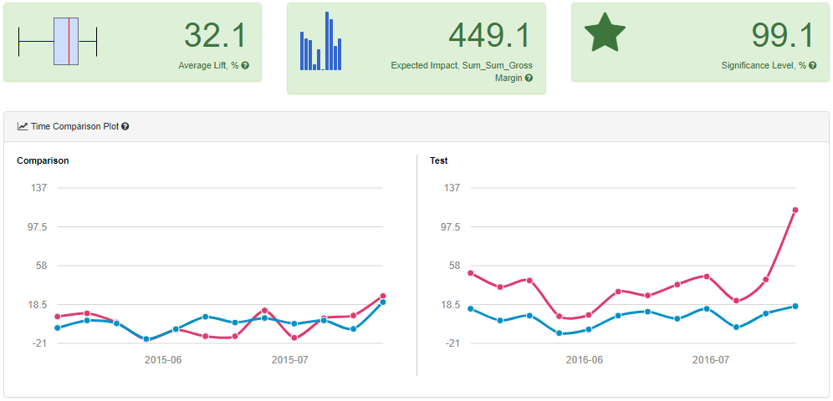

Fig. 4.1. West region AB test analysis report.

b. Central – the report shows that the average lift as a result from rolling out the update menu showed a 36.3% improvement at a significance of 99.2% over the control stores, meaning, approximately $682 per store per week.

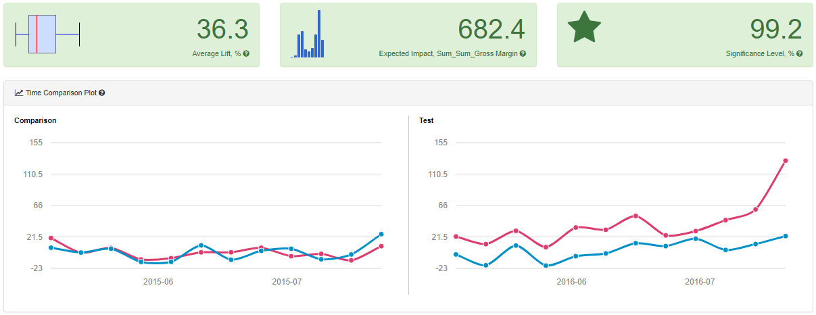

Fig. 4.2. Central region AB test analysis report.

1. What is the lift from the new menu overall?

The report shows that overall the average lift as a result from rolling out the update menu showed a 34.2% improvement at a significance of 100% over the control stores, meaning, approximately $566 per store per week.

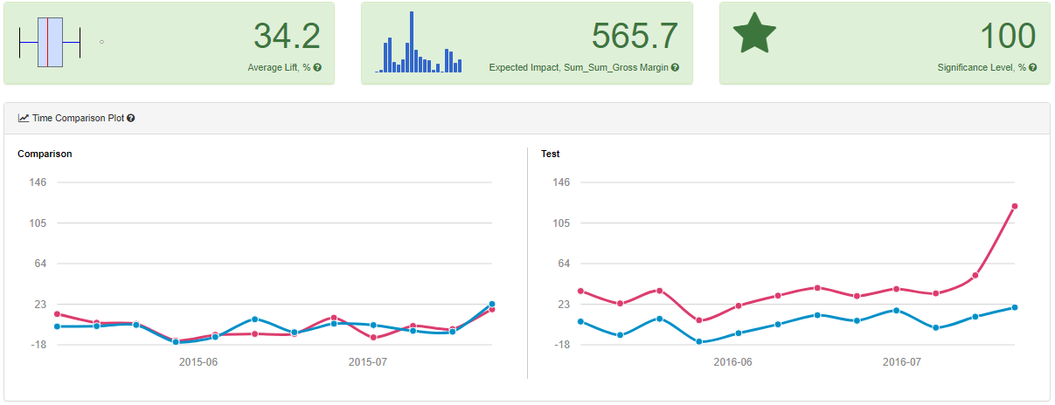

Fig. 4.3. Overall region AB test analysis report.